UNIT 3 ELECTRO CHEMICAL CELLS
PART - A
1. What is Single Electrode Potential? (May 15)
Potential difference between an electrode (immersed metal) and surrounding solution of its own salt is called as single electrode potential.
M (s) M^{n+} (aq) + ne⁻
2. What is electromotive force (e.m.f.) of a cell? (Jan 15, May 15)
The difference in potential, which causes current flow from electrode of higher potential to lower potential, is called electromotive force of cell.
3. What is electromotive series or electrochemical series? (May 11, May 13, Jan 14)
Electrochemical series is the arrangement of various electrodes in increasing order of their standard electrode potential. In this series, system having a greater tendency to get reduced compared to hydrogen ions are given a positive value and those having a smaller tendency to get reduced are given negative values.
4. Write functions of salt bridge in an electrochemical cell. (May 14)
- Salt bridge is a U-tube containing saturated KCl or NH₄NO₃ in agar-agar gel.
- Salt bridge separates two electrolytes physically and provides electrical contact
between two electrolytes.
- It maintains the electrical neutrality by allowing migration of ions.
5. Define a reference electrode? Mention its applications. (May 15)
Electrode of standard potential, with which the potential of other electrode can be compared, is called a reference electrode. Standard Hydrogen electrode is used as primary reference electrode and Calomel electrode, Glass electrode are used as secondary reference electrodes. They are used to find the pH of an unknown solution.

6. Give the merits and demerits of glass electrode. (May 19)
Merits
- Setting up is simple and easy to use.
- Small quantity of solution is sufficient and oxidizing and reducing agents can be used.
Demerits
- Resistance of glass membrane is very high and electronic potentiometer is needed.
- Cannot be used in strong alkaline solution.

7. Glass electrodes cannot be used for solution of pH above 10. Why? (Jan 15, Nov 19)
Above pH 10, cations of solution affect glass interface and make the electrode useless.
8. What are batteries? How Batteries differ from a Cell? (May 13, Sep 20)
A device which stores chemical energy for later release of electricity is known as Battery. A cell is a single unit device which converts chemical energy into electric energy. A battery usually consists of group of cells.
A battery is either a primary battery or a secondary battery meaning it is rechargeable or non-chargeable. A cell is usually light and compact as it has a single unit.
9. Difference between an electrolytic cell and a galvanic cell (Nov 18, May 19, Nov 19)
Electrochemical cell (Galvanic Cell) | Electrolytic cell
A Galvanic cell converts chemical energy into electrical energy. | An electrolytic cell converts electrical energy into chemical energy.
Here, the redox reaction is spontaneous and is responsible for the production of electrical energy. | The redox reaction is non spontaneous and electrical energy has to be supplied to initiate the reaction.
The two half-cells are set up in different containers, being connected through the salt bridge or porous partition. | Both the electrodes are placed in a same container in the solution of molten electrolyte.
Here the anode is negative and cathode is the positive electrode. The reaction at the anode is oxidation and that at the cathode is reduction. | Here, the anode is positive and cathode is the negative electrode. The reaction at the anode is oxidation and that at the cathode is reduction.
The electrons are supplied by the species getting oxidized. They move from anode to the cathode in the external circuit. | The external battery supplies the electrons. They enter through the cathode and come out through the anode.

10. List out any three requirement of a good battery. (Jan 14)
- It should be easy for construction.
- EMF of the battery should be constant.
- It should be rechargeable.
11. Write short note on Nickel-Cadmium battery. (Nov 19)
Nickel–cadmium battery is a reversible cell. It consists of cadmium anode and cathode composed of a paste of NiO(OH). The cell reactions is,
2 NiO(OH) + Cd + 2 H₂O Cd(OH)₂ + 2 Ni(OH)₂
Nickel-cadmium battery is a portable, rechargeable cell and its cell voltage is fairly constant of about 1.4 V.

12. Give differences between primary and secondary batteries. (Nov 10, Jan 13, May14)
Primary Battery | Secondary Battery
Cell reaction is not reversible  It can not be recharged  Eg. Dry cell | Cell reaction is reversible  It can be recharged  Eg. Lead-Acid storage battery

13. What is the role of MnO₂ in Leclanche cell? (May 16)
A cell without fluid component is called dry or Leclanche cell. The anode of the cell is zinc can contain an electrolyte consisting of NH₄Cl, ZnCl₂ and MnO₂. The cathode reaction involves the reduction of MnO₂ to a series of compounds having Mn in +3 oxidation state (Mn₂O₃).
14. What is fuel cell? Write the advantages of H₂-O₂ fuel cell? (May 12, May 14, Nov 19)
Fuel cell is a device for producing electricity by converting the chemical energy of a conventional fuel and oxygen into electrical energy. The familiar example is H₂-O₂ fuel cell.
Advantages of H₂-O₂ fuel cell
- It acts as an auxiliary energy source in space vehicles and submarines.
- The product H₂O is a valuable source of fresh water by astronauts.
15. Difference between Fuel Cell and Battery. (Nov 19)
The biggest difference between the two is that a battery stores energy, while a fuel cell generates energy by converting available fuel. A fuel cell can have a battery as a system component to store the electricity it's generating. Essentially, there is a small explosion as the fuel is combusted.
16. Calculate standard e.m.f. of a galvanic cell. The standard reduction potential of zinc and copper is – 0.76 V and + 0.34 V respectively. (Sep 20)
Given that E° _{Cu2+ / Cu} = + 0.34 V and E°_{Zn2+ / Zn} = – 0.76 V
E _{cell} = E _{cathode} – E_{anode}
= E° _{Cu2+ / Cu} – E°_{Zn2+ / Zn}
= + 0.34 – (– 0.76) = 0.34 + 0.76 = 1.1 V
17. Determine the electrode potential of Cu²⁺ / Cu ₌ 0.5M at 25° C. E° _{Cu2+ / Cu} = 0.337 (Nov 18)
Given that concentration of Cu²⁺ = 0.5 M and w.k.t. E° _{Cu2+ / Cu} = 0.337
The Nernst equation is, E = E° + (0.0591 / n) log [Cu²⁺] at 25°C
= 0.337 + (0.0591 / 2) log (0.5)
E = 0.3281V
18. Determine the reduction potential of Pb electrode immersed in 0.018M Pb²⁺ solution at 25° C. E°_{Pb2+/Pb} = – 0.13 V (Sep 20)
Given that concentration of Pb²⁺ = 0.018 M E°_{Pb2+/Pb} = – 0.13 V
The Nernst equation is, E = E° + (0.0591 / n) log [Pb²⁺ ] at 25°C
= – 0.13 + (0.0591 / 2) log (0.018)
E = – 0.1815 V

19. Calculate emf of the following cell at 25˚C? Zn(s)/ZnSO₄ (0.1 M) ║CdSO₄ (0.01M)/Cd(s) given that (E˚Cd²⁺/Cd = -0.4V; E˚Zn²⁺/Zn = -0.76V) (Nov 19)
We know that E _{cell} = E _{cathode} – E_{anode} = E _{Cd}²⁺ _{/ Cd} – E_{Zn}²⁺ _{/ Zn}
According to Nernst equation,
E _{Cd}²⁺ _{/ Cd} = E° _{Cd}²⁺ _{/ Cd} + (0.0591 / 2) log (0.01) ;
E_{Zn2+ / Zn} = E°_{Zn2+ / Zn} + (0.0591 / 2) log (0. 1)
Therefore E _{cell} = [E° _{Cd}²⁺ _{/ Cd} + (0.0591 / 2) log (0.01)] – [E°_{Zn2+ / Zn} + (0.0591 / 2) log (0. 1)]
= E° _{Cd}²⁺ _{/ Cd} – E°_{Zn2+ / Zn} + (0.0591 / 2) log (0.01) – (0.0591 / 2) log (0. 1)
= -0.4-(-0.76) + (0.0591 / 2) log (0.01 / 0. 1)
= 0.3009V
20. What is the emf of concentration cell consisting of zinc electrodes, one immersed in 0. 5 M and the other in 0.05M at 25°C. (Two solutions are connected by a Salt Bridge. (May 19)
Electrode dipped in higher concentration acts as cathode and electrode dipped in lower concentration acts as anode.
The cell is Zn(s)/Zn²⁺ (0.05 M) || Zn²⁺(0.5 M)/Zn(s)
E.m.f. = (0.0591 / n) log (C₂ / C₁) at 25°C
E.m.f. = (0.0591 / 2) log (0.5 / 0.05)
= (0.0591 / 2) log 1
= 0.02955 V
PART - B
1. Derive the Nernst equation for single electrode potential. (Nov 10, Jan 13, May 14, Jan 15, Nov 16, May 17, Nov 18, May 19, Sep 20)
An expression relating electrode potential of an electrode to concentration of its ions in solution has been given by Nernst equation.
Derivation
Consider a redox reaction: M^{n+} (aq) + n e – M (s)
For a reversible reaction at equilibrium, the free energy change (ΔG) and its equilibrium constant (K) are inter related as,
ΔG = RT ln K + RT ln [Product] / [Reactant]
where R is gas constant and T is temperature.
When concentrations of reactants and products are unity, then,
ΔG° = RT ln K
where ΔG° is standard free energy change.
Therefore ΔG = ΔG° + RT ln [Product] / [Reactant]
This equation is popularly known as Vant Hoff reaction isotherm.
In a reversible reaction, electrical energy is produced at the expense of free energy decrease. Let E be the electrode potential forms between metal and solution of its own salt of valency n. Now the electrical energy required transferring 1 g equivalent of metal ion from metal to solution of its own salt would be nFE.
Thus, decrease in free energy of a metal will produce nFE electrical energy.
i.e. – ΔG = nFE
where ΔG is the free energy change; F is 1 Faraday of electricity (96,500 Coulombs); n is number of valence electrons; E is the electrode potential.
At standard condition – ΔG° = nFE°
where E° is the standard electrode potential
Substituting the values of ΔG and ΔG° in the Vant hoff equation, we get
– nFE = – nFE° + RT ln [M] / [M^{n+}]
as concentration of metal, M is unity
– nFE = – nFE° + RT ln 1 / [M^{n+}]
– nFE = – nFE° – RT ln [M^{n+}]
dividing the above equation by – nF, we get,
E = E° + (RT / nF) ln [M^{n+}]
Converting ln to log,
E = E° + (2.303 RT / nF) log [M^{n+}]
This expression is known as Nernst equation for electrode potential.
At 25°C, R = 8.314 J/K/mole; F = 96,500 Coulombs; T = 25°C,
the Nernst equation becomes,
E = E° + (0.0591 / n) log [M^{n+}] at 25°C
From equation, it is clear that,
(i) if concentration of solution is increased, electrode potential increases.
(ii) if temperature increases, the electrode potential increases.
This equation may be used to calculate e.m.f. of cells when concentration of reactants and products of the cell reaction are known.
2. Explain electromotive or electrochemical series? (Jan 13, May 15)
Electrochemical series is an arrangement of various electrodes in increasing order of their standard electrode potential. In this series, the system having a greater tendency to get reduced compared to hydrogen ions are given a positive value and those having a smaller tendency to get reduced are given negative values.

Electrochemical Series
Half-cell representation E° (V) Nature
Li⁺/Li – 3.01 Anodic
Mg²⁺/Mg – 2.37
Zn²⁺/Zn – 0.76
Fe²⁺/Fe – 0.44
H⁺/H₂ 0.00 Reference
Cu²⁺/Cu + 0.34
Ag⁺/Ag + 0.80
F²⁺/F– + 2.65 Cathodic
Applications of electrochemical series.
(i) Relative ease of oxidation or reduction
Relative tendencies of the metals to get ionized into solution can be noted from electrochemical series. A system with higher value of standard reduction potential has a greater tendency to undergo reduction. The positive sign indicates reduction reaction. For example, standard reduction potential of fluorine (F₂/F) system has higher positive value (+ 2.87 V). Thus F– ions are very easily reduced to F₂ or conversely, F₂ is oxidized with great difficulty to F– ions.
The negative sign indicates possibility of oxidation reaction. Standard reduction potential of Li (Li⁺/Li) system is least (– 3.05V). Hence reduction of Li⁺ is very difficult or Li is easily oxidized to Li⁺.
(ii) Replacement tendency
Higher value of reduction potential shows a greater tendency to assume the reduced form. Thus knowledge of electrode potential gives an indication of relative replacement tendency.
For example, to know whether Cu will displace Zn from solution or vice-versa, the answer is derived from electrochemical series.
Standard reduction potential: Eº_{Cu2+/Cu} = + 0.34 V and for Eº_{Zn2+Zn} = – 0.76 V. So Cu²⁺ can be reduced easily to Cu than Zn²⁺ to Zn, hence zinc will displace copper from the solution of copper sulphate. Thus the reaction will occur in the direction.
Zn + Cu²⁺ Zn²⁺ + Cu
Thus metals which lie higher in series (oxidation potential) will displace metal which lie lower in the series (reduction potential) from the solution.
(iii) Predicting spontaneity of redox reaction
From the e.m.f. (E) value of complete cell reaction, spontaneity of the redox reaction can be predicted. Thus,
- if ΔG = – ve E = + ve cell reaction is feasible, i.e., spontaneous
- if ΔG = + ve E = – ve cell reaction is non-spontaneous
- if ΔG = 0 E = 0 cell reaction is in equilibrium.
(iv) Calculation of standard e.m.f. of the cell
Using E° of anode half-cell and cathode half-cell, the standard e.m.f. can be calculated.
E°_{cell} = E°_{cathode} – E°_{anode}
(v) Calculation of equilibrium constant
Standard electrode potential, ΔG° = RT ln K_{eq}
By substituting the value of ΔG°
nFE° = RT ln K_{eq}
ln K_{eq} = nFE° / RT; log K_{eq} = nFE° / 2.303RT
log K_{eq} = (nE° / 0.0592 V)
Thus from the value of E° for a cell reaction, its equilibrium constant (K_{eq}) can be calculated.
(vi) Displacement of Hydrogen
Metal with negative reduction potential will displace hydrogen from an acid solution.
Zn + H₂SO₄ ZnSO₄ + H₂ (E° of zinc = – 0.76 V)
Metal with positive reduction potential will not displace hydrogen from acid solution.
Ag + H₂SO₄ no reaction (E° of silver = + 0.8 V)
(vii) Nature of Corrosion
The anodic metals or more active metals in the electrochemical series are more prone to corrosion. The cathodic metals or more noble metals are less prone to corrosion.
3. Explain electrochemical cell by construction of Daniel cell. (Jan 11, Nov 19)
An electrochemical cell is a device in which a redox reaction is utilized to get electrical energy and commonly referred as Voltaic or Galvanic Cell.
A cell is made up of two electrodes namely anode, cathode and an electrolyte. The electrons transferred in a redox reaction are utilized as a source of producing electrical energy. The electrode in which oxidation occurs is called anode; while the electrode where reduction occurs, is called cathode. The practical application of an electrochemical cell is Daniel cell.

Cell Construction
In Daniel cell, a zinc electrode is partially immersed in 1M ZnSO₄ solution and a copper electrode in 1M CuSO₄ solution. Each electrode is referred as a half cell. A salt bridge interconnects two solutions. Salt bridge is a U-tube containing saturated KCl or NH₄NO₃ in agar-agar gel. It provides electrical contact between two compartments and also helps to maintain electrical neutrality by allowing migration of ions.
If zinc and copper electrodes are connected from outside, electrons flow from zinc to copper, since zinc is oxidized and copper is reduced. Flow of electrons is indicated by voltmeter placed in the circuit.
The electrode reaction occurs in the Daniel cell are,
At anode (negative electrode) Zn Zn²⁺ + 2 e – (oxidation)
At cathode (positive electrode) Cu²⁺ + 2 e – Cu (reduction)
Cell reaction (redox reaction) Zn + Cu²⁺ Zn²⁺ + Cu
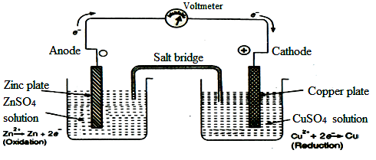

The tendency of Zn to form Zn²⁺ is greater than the tendency of Zn²⁺ to get deposited as Zn and hence zinc metal acquires a negative charge. Since oxidation takes place in zinc electrode by liberation of electrons, it is called negative electrode or anode.
Tendency of copper to go into solution is less than tendency of Cu²⁺ to get deposited as Cu and hence copper electrode becomes positively charged. Since reduction takes place in copper electrode by acceptance of electrons, it is called positive electrode or cathode.
Thus the number of electrons liberated in one half-reaction is equal to the number of electrons consumed in other half-reaction. The electrons released by oxidation reaction flow through the external wire and are consumed by copper ions at cathode. As soon as the connection made, current starts flowing as indicated by the voltmeter or ammeter due to flow of electrons. The e.m.f. of Daniel cell is 1.1 Volts.
4. Explain determination of emf of cell using Potentiometric or Poggendorf method? (May 12, May 13, Jan 14, May 14, Jan 15, May 15, Jan 16, Nov 17)
Principle
The e.m.f. of a test cell can be determined by applying an equal and opposite external adjustable potential from an external source. The applied potential is determined when it prevents the current from flowing in given cell. Thus the applied potential is equal in magnitude of e.m.f. of test cell.
When care is taken during the e.m.f. measurements, current taken from the cell is vanishingly small and concentrations of ions in the cell are not altered appreciably during the measurements. Hence e.m.f. of the cell remains constant and its value can be determined with very high degree of accuracy. It is necessary to have a standard cell whose e.m.f. is known and Weston cadmium cell is used for this purpose.
Thus an adjustable potential is applied to oppose the e.m.f. and exact point of resistance in the potentiometer is found out with help of a slider moving on a wire. Resistance offered by the cell is the distance-measured until the null point detected by null deflection in Galvanometer.
Description
Potentiometer consists of a uniform wire AB of high resistance and a storage battery B of constant and large e.m.f. which is connected to the ends A and B of the wire through a Rheostat R of adjustable resistance.
A standard cell (Weston cell) S and unknown cell X whose e.m.f. is to be determined are connected to A with poles in same direction as that of battery using a double pole double through (DPDT) key. A galvanometer G through jockey J is connected to other terminal B.

Circuit Diagram
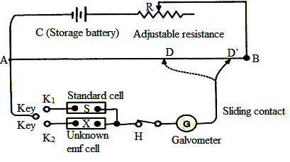

Working
(i) First circuit is completed through standard cell S of known e.m.f. by introducing key K₁. The sliding contact is moved along the wire AB, till point D is reached, when no deflection is observed in the galvanometer. The potential difference between A and D balances e.m.f. of the standard cell with that of the battery. Now e.m.f. of the standard cell is directly proportional to the distance AD.
e.m.f. of Standard cell (E_{S}) = length AD
(ii) Unknown cell X, whose e.m.f. is to be determined is included in another circuit by connecting the pole A through a galvanometer and sliding contact. The second circuit is completed by introducing key K₂. The sliding contact is moved along the wire AB, till point D’ is reached, when no current flows through the galvanometer. At this point, the potential difference between A and D’ balances e.m.f. of the unknown cell with that of the battery. Thus e.m.f. of unknown cell is proportional to distance AD’.
e.m.f. of unknown cell (E_{X}) = length AD’
In both occasions e.m.f. is compensated, this is a compensation cell method.

Calculation

The e.m.f. of unknown cell can be calculated as follows:

e.m.f. of Standard cell (E_{S}) length AD
=

e.m.f. of unknown cell (E_{X}) length AD’

E_{S} AD
=

E_{X} AD’
Therefore, e.m.f. of the unknown cell E_{X} = (AD’/AD) x E_{S}
Thus by knowing e.m.f. of standard cell, e.m.f. of unknown cell can be calculated Potentiometrically.
Standard cell / Weston Cadmium standard cell
Standard cell is a source of unvarying potential which is capable of giving constant and reproducible e.m.f. and has a negligible change in e.m.f. with temperature. It consists of H-shaped glass vessel with two arms. Each arm has a platinum wire and sealed at the bottom.
Positive electrode contains mercury over which a paste of mercurous sulphate and mercury is placed. Negative electrode consists of an amalgam of Cd and Hg, containing about 15% of Cd by weight. Over both electrodes some crystals of cadmium sulphate are sprinkled to maintain the saturation at all times.
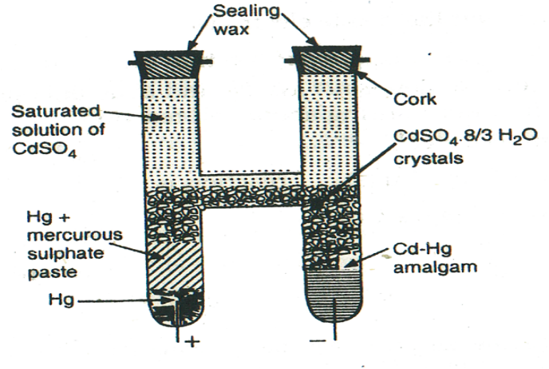

Remaining part of the cell is filled with saturated solution of cadmium sulphate. Upper parts of the tube are closed with corks and sealed. When the cell operates, reactions at two electrodes are,
At anode (negative electrode) Cd (s) Cd²⁺ (aq) + 2e –
At cathode (positive) Hg₂SO₄ (s) + 2 e – 2 Hg (l) + SO₄^{2–} (aq)
The e.m.f. of this cell is 1.0181 V at 25°C and variation with temperature is very low. This cell works for many years at a stretch without any voltage changes.
5. Explain theory and application of Concentration cells. (May 11, Nov 11, Jan 14)
A concentration cell is an electrochemical cell which produces electrical energy by transfer of matter or substance from a system of higher concentration to a system of lower concentration. In this there is no net chemical reaction.
Thus the galvanic cell which produce electric current only due to the difference in concentration of electrolyte solution are called concentration cell. There are two types of concentration cell:
(i) Electrode concentration cell: It consists of two similar electrodes of different composition, which are in contact with same electrolyte of same concentration.
Eg.: Two hydrogen electrodes at different pressure dipped in common hydrochloric acid electrolyte.
(ii) Electrolyte concentration cell: It consists of two electrodes of same metal, which are in contact with same electrolyte of different concentration. The two half cells may be joined by a salt bridge.
Eg.: Two copper electrodes dipped in different concentration copper sulphate solution. It can be represented as, Cu / Cu²⁺ (C₁) || Cu²⁺ (C₂) / Cu
Theory in Electrolyte Concentration cell
When a metal electrode M is dipped in a solution containing its metal ions M^{n+}, then a potential is developed at the electrode. The electrode potential E varies with concentration C of the metal ions according with Nernst equation is given as,
E = E° + (2.303 RT / nF) log C
At 25°C, E = E° + (0.0591 / n) log C
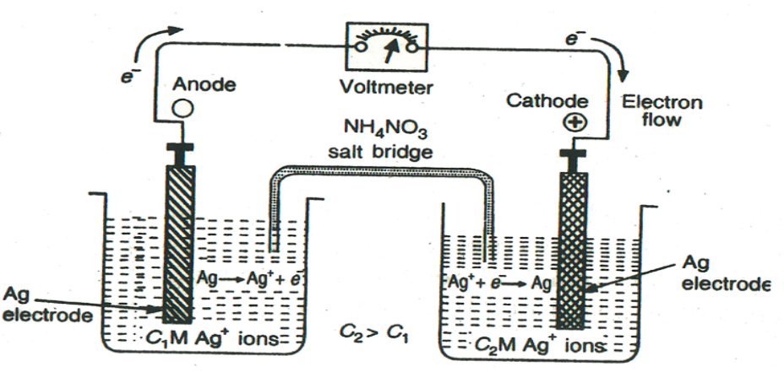Consider a general electrolyte concentration cell in which two half cells are made up of similar electrodes and electrolytes but the concentration of reactive ions around the electrodes are different.

It can be represented as M / M^{n+} (C₁) || M^{n+} (C₂) / M where C₂ > C₁
where C₁ and C₂ are concentrations of metal ions which are in contact with two electrodes.Metal immersed in higher concentration acts as cathode because of high osmotic pressure of solution whereas metal immersed in lower concentration acts as anode.
The e.m.f. of cell is determined as,
E_{Cell} = E_{right} – E_{left} or = E_{cathode} – E _{anode}
where E_{cathode} and E_{anode} are half cell potential of cathode and anode respectively.
The half cell potentials can be determined by Nernst equation as,
E_{Cell} = [E° + (0.0591/n) log C₂] – [E° + (0.0591/n) log C₁]
= (0.0591/n) log C₂ – (0.0591/n) log C₁
e.m.f. of a conc. cell = (0.0591/n) log (C₂ / C₁) at 25°C where C₂ > C₁
In the above concentration cell, reactions occurring at two half cells are,
At anode (left electrode) M M^{n+} (C₁) + ne – (oxidation)
At cathode (right electrode) M^{n+} (C₂) + ne – M (reduction)
Overall cell reaction M^{n+} (C₂) M^{n+} (C₁)
It is clear from above reactions that in concentration cell there is no net chemical reaction. Thus the e.m.f. developed is due to transfer of metal ions from solution of higher concentration to solution of lower concentration.
Applications
(i) Determination of solubility of sparingly soluble salt: Solubility and solubility product of sparingly soluble salts like AgCl, PbSO₄, etc., can be calculated by measuring the e.m.f. of a concentration cell.
(ii) Determination of valency of an ion: By substituting measured value of e.m.f. of a concentration cell, values of C₁ and C₂ in the equation, E_{cell} = (0.0591 / n) log (C₂ / C₁) at 25°C, number of electrons, n involved in the cell reaction can be calculated.
6. What is a reference Electrode? Explain the construction, application and limitations of Hydrogen electrode. (Jan 11, May 12, Jan 14, May 14, Nov 16, May 18)
Electrode of standard potential with which we can compare the potential of other electrode is called as Reference electrode. The best reference electrode used is Standard Hydrogen Electrode, whose electrode potential at all temperatures is taken as zero.
However, in view of difficulties occurring in setting up of a hydrogen electrode, secondary reference electrodes like Calomel electrode, Glass electrode are used.

Hydrogen Electrode
Primary reference electrode is Normal Hydrogen Electrode (NHE) or Standard Hydrogen Electrode (SHE). In this gas electrode, inert platinum electrode is in contact with hydrogen gas at one atmosphere pressure and also with 1M H⁺ ions of HCl solution.
Construction
Hydrogen electrode consists of a small platinised platinum foil that is connected to a platinum wire which is sealed through the end of a glass tube. This tube is surrounded by another co-axial tube, which is sealed to the inner glass tube at the top. The outer glass tube is provided with a side-arm for passing hydrogen gas in-between the space.
Bottom of the outer tube is made into bell shape around platinum foil through which hydrogen gas is allowed to escape. The platinum foil is coated with a layer of finely divided platinum which adsorbs the hydrogen gas and it also speed up the equilibrium between hydrogen gas and hydrogen ions. This electrode, when dipped in 1M HCl solution and hydrogen at 1 atmosphere is passed through the opening, yields a normal or standard hydrogen electrode. E.m.f. of cell has arbitrarily been fixed at zero.
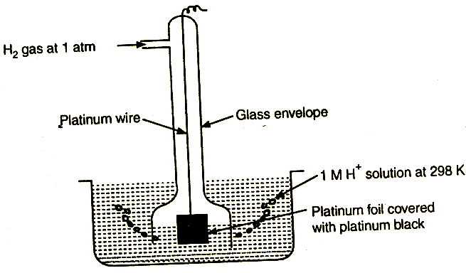

Representation
Pt, H₂ (1 atm) / H ⁺ (1M)
Reaction 2 H ⁺ (aq) + 2 e – H₂ (g) E° = 0 V
Application
Hydrogen electrode may be used to find pH value of unknown solution. The solution whose pH is to be determined is taken in a vessel and a platinum electrode is half dipped in it. Hydrogen gas at 1 atmosphere is bubbled through solution at a slow rate and platinum catalyses the reaction.
Depending upon the concentration of H⁺ ions in solution to be determined, a definite potential is developed at the platinum electrode.
E = E° – (2.303 RT / nF) log [H₂] / [H⁺]
at 25°C, E° = 0
E = 0 – (0.0591/1) log 1/ [H⁺]
E = – 0.0591 pH
This half-cell so formed is connected to a standard hydrogen electrode. The two solutions are separated by a salt bridge to eliminate liquid junction potential. The e.m.f. of complete cell is then determined by using a potentiometer. Since e.m.f. of reference electrode is zero, observed e.m.f. gives directly the e.m.f. of half cell containing the solution under test.
Thus E_{cell} = E_{right} – E_{left}
= 0 – (– 0.0591 pH) = 0.0591 pH
Therefore pH = E_{cell} / 0.0591 V.
Thus pH of solution under test can be determined using hydrogen electrode.
Limitations
- Hydrogen electrode is easily affected by compounds of Hg, As, S and oxidizing agents like Fe³⁺, MnO₄–, Cr₂O₇^{2–}, etc. Hence this electrode cannot be used in solution containing redox systems.
(ii) It cannot be used when solution under test has ions of many metals.
- Hydrogen gas has to be carefully controlled and it can form explosive mixture with air. Hence it is difficult to set up hydrogen electrode.

7. Explain construction and applications of a Calomel electrode. (Nov 10, Nov 11, Jan 13, May 13, Jan 14, May 14, Jan 15, May 18, Nov 19, Sep 20)
Calomel electrode is a secondary reference electrode and it is the most commonly used reference electrode. It consists of a metal, which is in contact with its insoluble salt which is further in contact with a saturated solution of soluble salt having same anion. Calomel electrode is the mercury – mercurous chloride electrode.
Potential of calomel electrode, on hydrogen scale has been found to vary with concentration of potassium chloride solution used.
KCl Electrode Name of
concentration potential V electrode
0.1 N 0.3335 Decinormal calomel electrode
1.0 N 0.2810 Normal calomel electrode
Saturated 0.2422 Saturated calomel electrode
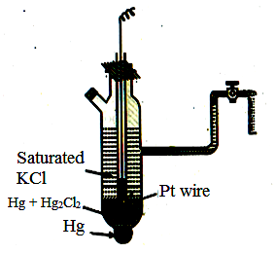

Construction
It consists of glass tube containing mercury in bottom, over which a paste of mercury-mercurous chloride is placed. Remaining portion of tube is filled with solution of normal / decinormal / saturated solution of KCl.
A platinum wire, dipped in mercury layer is used for making electrical contact. The glass tube consists of two side tubes. One is used to fill KCl solution and the other is used for making electrical contact with salt bridge.
Representation
Hg, Hg₂Cl₂ / KCl (saturated)
Reaction
Hg₂Cl₂ (s) + 2 e– 2 Hg (l) + 2 Cl – E° = 0.2422 V
Application
Calomel electrode may be used to find pH value of an unknown solution by coupled with a hydrogen electrode containing solution of unknown pH.
The complete cell is represented as,
Pt, H₂ (1 atm) / H⁺ (unknown) || KCl (sat) / Hg₂Cl₂ (s), Hg
The e.m.f. of cell is calculated as follows:
E_{cell} = E_{right} – E_{left} = E_{calomel} – E_{hydrogen}
E_{cell} = 0.2422 + 0.0591 pH
pH = (E_{cell} – 0.2422) / 0.0591
Thus pH of unknown solution can be determined using calomel electrode.
8. What is a Glass electrode? Explain the construction, application and merits and demerits of a Glass electrode. (Jan 16, May 17, Nov 19)
When two solutions of different pH values are separated by a thin glass membrane, difference of potential will develop between two surfaces of membrane. The potential difference developed is proportional to the difference in pH value. The glass membrane functions as an ion-exchange resin and an equilibrium is set up between Na⁺ ions of glass and H⁺ ions in solution. The potential difference varies with H⁺ ion concentration over a range of pH of the test solution from 0 to 10 at 25°C.
Construction
Glass electrode consists of a thin walled glass bulb with a long neck. The glass bulb is made up of a special glass having low melting point and high electrical conductivity.
The glass bulb is filled with 0.1N HCl solution and a platinum electrode or silver wire coated with silver chloride is inserted in the glass bulb to make electrical contact.
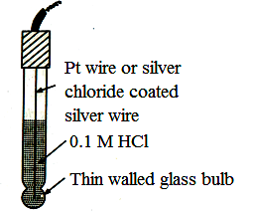

HCl solution in the bulb furnishes a constant H⁺ ion concentration. It has been observed that a potential difference exists at the interface between glass and solution containing H⁺ ions. The magnitude of this difference of potential at 25°C is given by,
E_{G} = E°_{G} + 0.0591 log [H⁺]
E_{G} = E°_{G} – 0.0591 pH
where E°_{G} is standard electrode potential of the given glass electrode and it depends upon the nature and composition of glass membrane.
Representation
Pt, HCl (0.1N) / glass (or) Ag, AgCl / HCl (0.1N) / glass

Application
Glass electrode is used as an internal reference electrode for determining pH of solutions, especially coloured solutions.
It is mostly used for determining pH of test solution from 0 to 10. Usually saturated calomel electrode is used as the second electrode.
In order to determine pH of unknown solution, the glass electrode is placed in solution under test and this half-cell is coupled with saturated calomel electrode.
The complete cell is represented as,
Ag, AgCl / HCl (0.1N) / glass || Unknown solution / SCE
E.m.f. of cell is measured using potentiometer. Since resistance is very high, special electron-tube voltmeters are used to measure e.m.f. of cell.
The e.m.f. of complete cell is given by,
E_{cell} = E_{right} – E_{left} = E_{calomel} – E_{glass}
E_{cell} = 0.2422 – (E°_{G} – 0.0591 pH)
= 0.2422 – E°_{G} + 0.0591 pH
0.0591 pH = E_{cell} – 0.2422 + E°_{G}
Therefore, pH = (E_{cell} – 0.2422 + E°_{G} ) / 0.0591
E°_{G} value of glass electrode determined by using a solution of known pH. Thus pH of unknown solution can be determined using calomel electrode.
Merits
- Set up is simple and easy to use.
- A small quantity of solution is sufficient for determination of pH as the equilibrium of reaction is rapidly achieved.
- It can be used in coloured solutions containing oxidizing and reducing agents and it is
not easily poisoned.
Demerits
(i) Although glass membrane is very thin, resistance of glass membrane used in the bulb is very high, which cannot be measured by ordinary potentiometer. Therefore electronic potentiometers are needed for the measurement.
(ii) This electrode can be used only in solutions with pH range of 0 to 10 and it cannot be used in strong alkaline solution. In such cases, special type of glass must be used.
9. Explain Laclanche or Dry Cell, its uses and disadvantages. (May 10, Nov 19)
Dry cell is a cell without fluid component which is the most familiar of all batteries. Anode of the cell is a zinc container. It contains the electrolyte consisting of NH₄Cl, ZnCl₂ and MnO₂ to which starch is added to make it thick paste so that it is less likely to leak. A carbon rod serves as cathode, which is immersed in electrolyte in centre of the cell.
Oxidation takes place in negative zinc electrode which acts as anode.
At Anode: Zn Zn²⁺ + 2 e – (oxidation)
Reduction takes place in positive electrode which is quite complex and it involves mainly the reduction of MnO₂.
At Cathode: 2 MnO₂ + H₂O + 2 e – Mn₂O₃ + 2 OH– (reduction)
Net cell reaction: Zn + 2 MnO₂ + H₂O Zn²⁺ + Mn₂O₃ + OH–
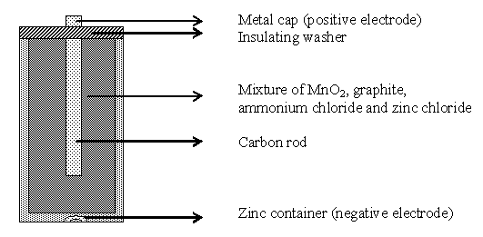

Resulting OH– ions react with NH₄Cl to liberate NH₃, which disturbs current flow.
NH₄Cl + OH– NH₃ + H₂O + Cl–
This is prevented by reaction of NH₃ with Zn²⁺ ions from ZnCl₂ to precipitate as sparingly soluble complex.
Zn²⁺ + 2 NH₃ + 2 Cl– [Zn(NH₃)₂]Cl₂
These are secondary reactions and not involved in electrode reaction. Hence they do not contribute to potential of the cell.
Dry cell is a primary cell, since various reactions involved cannot be reversed by passing electricity back through the cell. It is cheap to make and e.m.f. of cell is about 1.5 V.
Uses
Dry cell is used in torches, radio, calculators, flash lights, etc.

Disadvantages
(i) When current is drawn rapidly from it, products build up on electrodes, thereby causing drop in voltage.
(ii) Since the electrolytic medium is acidic, zinc metal dissolves slowly, thereby the cell run down slowly, even if it is not in use.
10. Explain Lead – Acid storage cell or Lead accumulator and its uses. (Nov 11, Jan 13, May 13, Jan 14, May 14, Jan 15, Jan 16, Nov 16, Nov 17, Nov 18, May 19, Nov 19 )
A storage cell is one that can operate both as a voltaic cell and as an electrolytic cell. When operating as a voltaic cell, it supplies electrical energy and as a result becomes run down. It must be recharged to use it again. When recharged, the cell operates as an electrolytic cell. Thus, storage cell has the great advantage of its ability to work both ways, to receive electrical energy and also to supply it.
Charged cell is represented as, Pb / PbSO₄ (s) H₂SO₄ (aq) / PbO₂ (s), Pb
Common example of storage cell is Lead-Acid cell. It is a well known example of secondary cell. It essentially consists of two lead electrodes, one acts as anode and other lead electrode is covered with an adherent layer of lead dioxide on its surface, which acts as positive electrode. A number of lead plates (- ve plates) are connected in parallel and a number of lead dioxide plates (+ ve plates) are also connected in parallel.
Lead plates fits in between lead dioxide plates. Various plates are separated from adjacent ones by insulators like strips of wood or rubber. The entire combination is immersed in 20% dil. H₂SO₄ solution corresponding to a density of 1.2 at room temperature.
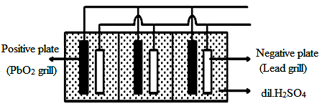

Discharging
When the storage cell is operating as a voltaic cell for supplying electrical energy, it is said to be discharging.
At anode, lead oxidizes to Pb²⁺ ions with release of electrons, which flow through the wire. The Pb²⁺ ions then combine with sulphate ions present in solution to precipitate lead sulphate.
At lead anode: Pb Pb²⁺ + 2 e –
Pb²⁺ + SO₄^{2–} PbSO₄
The electrons released from anode lead plate, flows to lead dioxide electrode. At cathode, lead dioxide undergoes reduction and gain electrons to form Pb²⁺ ions which then combine with SO₄^{2–} ions.
At lead dioxide cathode: PbO₂ + 2 H ⁺ + 2 e – Pb²⁺ + 2 H₂O
Pb²⁺ + SO₄^{2–} PbSO₄
At both electrodes lead sulphate is precipitated. In the process of discharging, i.e., when accumulator during use, the net cell reaction is,
Pb + PbO₂ + 2 H₂SO₄ 2 PbSO₄ + 2 H₂O + Energy
Each cell produces about 2 volts at concentration of 21.4% H₂SO₄ at 25°C.
Lead–acid storage cell commonly used in automobiles which is a combination of six such cells in series to form a battery with e.m.f. of 12 V.
Charging
During discharging, when both anode and cathode electrodes are covered with PbSO_{4,} the cell ceases to function as a voltaic cell. In order to recharge accumulator, reactions taking place during discharging are reversed by passing an external e.m.f. greater than 2 volts from a generator.
The + ve pole of generator is attached to + ve pole of battery.
At + ve terminal (anode):
PbSO₄ + 2 H₂O PbO₂ + 4 H⁺ + SO₄^{2–} + 2 e –
At – ve terminal (Cathode):
PbSO₄ + 2 e – Pb + SO₄^{2–}
The net reaction during charging process is,
2 PbSO₄ + 2 H₂O + Energy Pb + PbO₂ + 2 H₂SO₄
During charging process, the electrodes of cell are restored to their original conditions. Thus lead is deposited at cathode, lead dioxide is formed at anode and H₂SO₄ is regenerated in the cell. Due to increase in the concentration of H₂SO₄, the potential of battery increases.
The voltage of lead accumulator does not depend on size of cell or electrodes. Small or large, a lead cell always has the same potential for a given acid concentration.
Uses
Lead acid storage cells are widely used in laboratory, power stations, telephones and telegraphs, motors and cars, train, electric clocks, radio sets, calling bells, mines, hospitals, broadcasting stations, automobiles and distribution works. Large accumulators have also been used in submarines.
11. Explain Nickel – Cadmium battery with equations. (Nov 10, Jan 14, May 15, May17, Sep 20)
Nickel–cadmium battery is a reversible cell. It consists of cadmium anode and cathode composed of a paste of NiO(OH). The cell reactions are,
At Anode: Cd + 2 OH– Cd(OH)₂ + 2 e –
At Cathode: 2 NiO(OH) + 2 H₂O + 2 e – 2 Ni(OH)₂ + 2 OH–
Net reaction: 2 NiO(OH) + Cd + 2 H₂O Cd(OH)₂ + 2 Ni(OH)₂
The reaction can be readily reversed, because the products, Ni(OH)₂ and Cd(OH)₂, adhere to the electrode surfaces.
Nickel-cadmium battery is a portable, rechargeable cell and its cell voltage is fairly constant of about 1.4 V. Like dry cell, it can be packed in sealed container. It can be left for long period without any appreciable deterioration, since no gases are produced during discharging or charging.

12. Explain alkaline battery. (May 12, Nov 19)
Alkaline battery is an improved form of dry cell, in which NH₄Cl is replaced by KOH to get a gel. Graphite rod is surrounded by a paste containing MnO₂. The outside body is made of zinc. The cell reactions are,
Anode: Zn + 2 OH- Zn(OH)₂ + 2 e⁻
Cathode: 2 MnO₂ + H₂O + 2 e ⁻ Mn₂O₃ + OH⁻
Net reaction: Zn + 2 MnO₂ + H₂O Zn(OH)₂ + Mn₂O₃
Main advantages of alkaline battery over dry battery are,
- Zinc does not dissolve readily in a basic medium
- Alkaline battery maintains better its voltage as the current is drawn from it compared to dry cell
- Life of alkaline battery is longer than dry cell, since there is no corrosion of Zn.
Uses
Alkaline batteries used in camera flash light, calculators, watches, etc.
13. Explain the construction and working of H₂-O₂ fuel cell. What are the advantages and limitations of fuel cell? (May 13, Jan 14, May 14, Jan 15, May 15, Nov 16, May 17, May 19, Nov 19, Sep 20)
A fuel cell converts the chemical energy of fuels directly to electricity. The essential process in a fuel cell is,
Fuel + Oxygen Oxidation products + Electricity
One of the simplest and most successful fuel cell is hydrogen-oxygen fuel cell. It consists essentially of an electrolytic solution such as 25% KOH solution, and two inert porous electrodes. Hydrogen and oxygen gases are bubbled through anode and cathode compartment respectively, where the following reactions take place:
Anode : 2 H₂ + 4 OH⁻ 4 H₂O + 4 e⁻
Cathode : O₂ + 2 H₂O + 4 e⁻ 4 OH⁻
Net reaction: 2 H₂ + O₂ 2 H₂O
The standard emf of the cell,
Eº = Eº_{ox} + Eº_{red} = 0.83 V + 0.40 V = 1.23 V
In actual practice, emf of cell is 0.8 to 1.0 V. The only product discharged by cell is water. Usually, a large number of these cells are stacked together in series to make a battery, called fuel cell or flow battery.
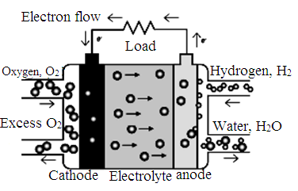

Application
Hydrogen-oxygen fuel cell is used as auxillary energy source in space vehicles (e.g., Apollo spacecraft), submarines or other military vehicles.
The weight of fuel battery sufficient for 15 days in space is ~250 kg. In H₂/O₂ fuel cells, the product is water, which is used by the astronauts.

